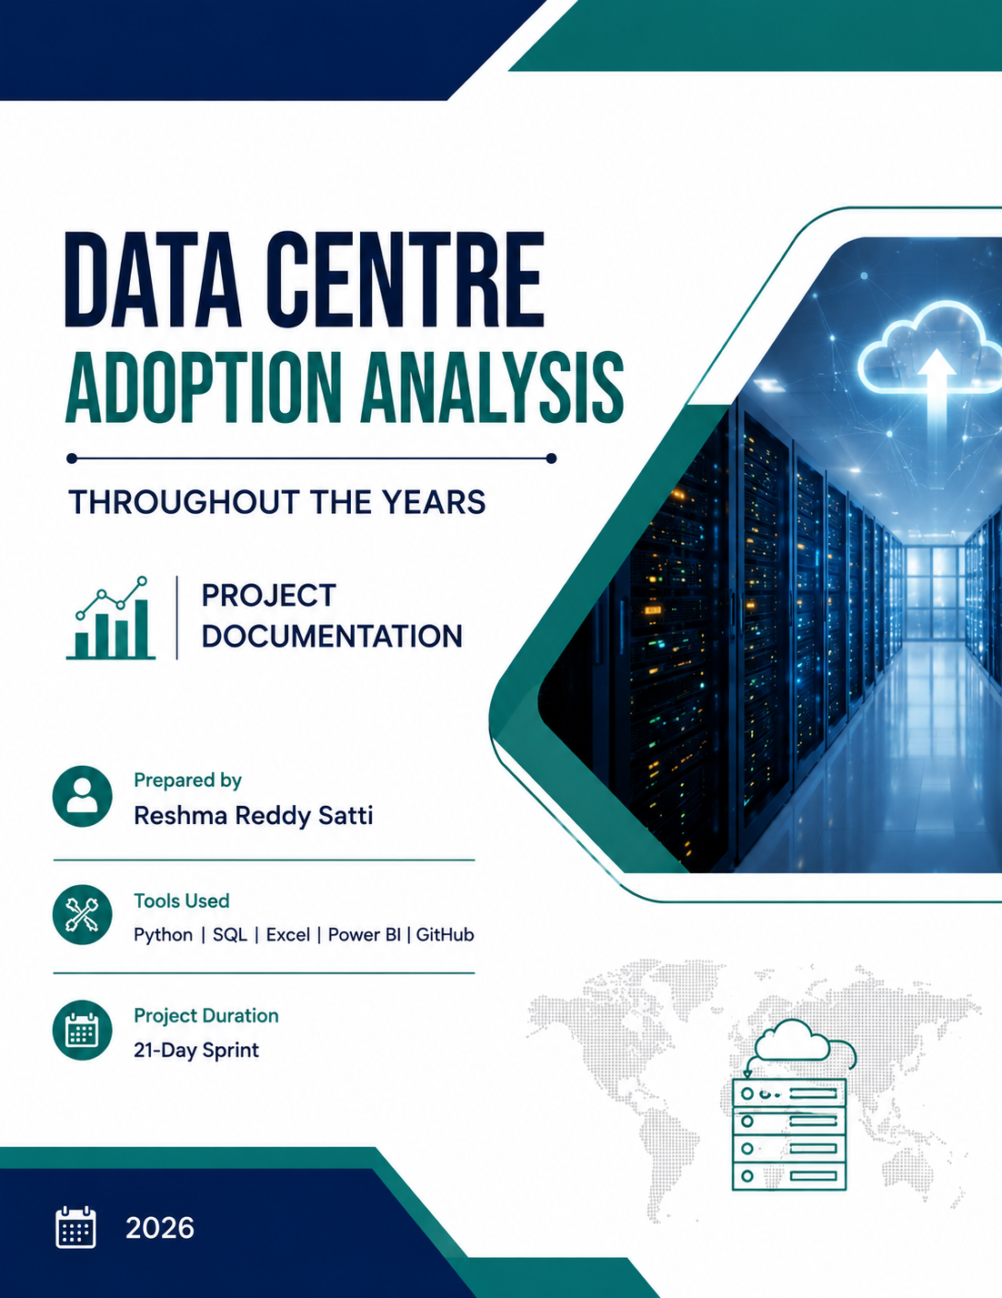

TABLE OF CONTENTS
1. Introduction
2. Problem Statement
3. Project Objectives
4. Dataset Overview
5. Data Dictionary
6. Tools and Technologies
7. Project Methodology
8. Data Cleaning
9. Excel Analysis
10. SQL Analysis
11. Python Analysis
12. Statistical Analysis
13. Power BI Dashboard
14. Key Findings
15. Recommendations
16. Limitations
17. 21-Day Work Summary
18. Conclusion
19. GitHub Repository

1. INTRODUCTION
This project focuses on analysing data centre adoption over the years. The main purpose is to understand how the number of data centres changes over time and how adoption differs across countries, cities and regions.
The project also studies internet penetration, electricity access, renewable energy percentage, GDP per capita and risk index. Excel, SQL, Python and Power BI were used at different stages, while GitHub was used to organise the project files.

2. PROBLEM STATEMENT
The main problem is to understand the growth and distribution of data centres across different locations and years. This project analyses data centre adoption over time and compares it across regions and cities while also studying related infrastructure, economic, environmental and risk factors.

3. PROJECT OBJECTIVES
- To understand the growth of data centres over the years.
- To compare data centre adoption across countries, cities and regions.
- To analyse the relationship between data centre count and other important factors.
- To clean and prepare the dataset for analysis.
- To perform data analysis using Excel, SQL and Python.
- To identify important trends, patterns and outliers.
- To create an interactive Power BI dashboard.
- To present useful business insights and recommendations.

4. DATASET OVERVIEW
The dataset used for this project is named Data_Centre_Adoption_Analysis_Realistic_20000.csv. The cleaned workbook supplied for the final documentation was checked before preparing this report.
Item | Details
Dataset name | Data_Centre_Adoption_Analysis_Realistic_20000.csv
Records | 20,000
Columns | 15
Year range | 2000–2025
Main adoption measure | Data_Center_Count
Missing values in cleaned file | 0
Duplicate rows in cleaned file | 0
Countries | 5
Cities | 5
Regions | 4
The dataset contains location, time, data centre, infrastructure, environmental, economic and risk-related fields. Year is used for time-based analysis, while City, Region and Electricity_Access are used for segmentation.

5. DATA DICTIONARY
Column | Type | Meaning
Country | Text | Country of the observation
City | Text | City associated with the observation
Region | Text | Geographical region
Year | Integer | Year of the observation
Data_Center_Count | Integer | Number of data centres
Latitude | Decimal | Latitude of the location
Longitude | Decimal | Longitude of the location
Population | Integer | Population of the location
Internet_Penetration | Percentage | Internet penetration level
Electricity_Access | Percentage | Level of electricity access
Renewable_Energy_Percentage | Percentage | Share of renewable energy
Water_Stress | Decimal | Water stress indicator
GDP_Per_Capita | Numeric | GDP per capita
Risk_Index | Decimal | Risk indicator
Average_Temperature | Decimal | Average temperature

6. TOOLS AND TECHNOLOGIES
Tool | Purpose
Excel | Data cleaning, filtering and pivot tables
SQL | Data cleaning, queries, aggregations and KPI analysis
Python | Data cleaning and exploratory/statistical analysis
Pandas | Data manipulation and analysis
Power BI | Dashboard and data visualisation
GitHub | Project files and documentation management
Jupyter Notebook | Python analysis and documentation

7. PROJECT METHODOLOGY
The project was completed in different stages. First, the dataset and project requirements were understood. Next, the data was profiled and cleaned using Excel, SQL and Python.
After cleaning, Excel pivot tables, SQL queries and Python analysis were used to identify patterns and trends. Statistical analysis was performed to understand distributions, outliers and relationships between variables.
Finally, the cleaned data was used in Power BI to create an interactive dashboard with KPI cards, trends, segmentation, filters and drill-downs.

8. DATA CLEANING
Data cleaning was performed before starting the main analysis. The dataset was checked for missing values, duplicate records, incorrect data types, invalid values and inconsistent categories.
Excel was used for filtering, conditional formatting and category checking. SQL and Python were then used to reproduce and validate the cleaning process.
The final cleaned dataset contains 20,000 rows and 15 columns. The cleaned dataset was checked for missing and duplicate values before further analysis.
Cleaning Check | Result
Row Count | 20,000
Column Count | 15
Missing Values | 0
Duplicate Rows | 0
Year Range | 2000–2025

9. EXCEL ANALYSIS
Excel was used for initial data inspection and analysis. Filters and conditional formatting were applied to check the data and identify possible inconsistencies.
Pivot tables were created to analyse the data based on City, Region and Electricity_Access. These summaries helped in understanding differences in data centre adoption and renewable energy percentage across different segments.
The cleaned Excel workbook was also saved as part of the project documentation.

Work Completed in Excel
- Applied filters to inspect the dataset.
- Used conditional formatting to support data checking.
- Checked and cleaned category values.
- Created pivot tables for City, Region and Electricity_Access.
- Prepared initial summaries and observations.

10. SQL ANALYSIS
SQL was used to load the dataset and perform structured data analysis. The cleaning steps were reproduced using SQL queries and the required data types were checked.
SQL queries were written to calculate aggregations based on Country, City, Region and Electricity_Access. KPI queries were also created to support the project analysis.
SQL views were created for important KPI outputs. Window functions were used with Year to analyse rankings, running totals and changes over time.

Main SQL Work
- Loaded the dataset into SQL and defined the required table structure.
- Reproduced data cleaning checks using SQL.
- Created grouped aggregations for the main analysis dimensions.
- Created KPI queries and SQL views.
- Used Year with window functions for time-based analysis.

11. PYTHON ANALYSIS
Python and Pandas were used to reproduce the data cleaning process and perform exploratory data analysis.
The dataset was checked for row count, missing values and duplicates. Summary statistics were calculated for important numerical variables. Histograms and other charts were used to understand distributions.
Segment analysis was also performed using City, Region and Electricity_Access. Additional analysis was carried out to understand outliers, trends and relationships between variables.

Main Python Work
- Loaded and inspected the cleaned dataset using Pandas.
- Checked row counts, null counts and duplicate records.
- Calculated summary statistics.
- Performed exploratory analysis on important variables.
- Analysed segments and distributions.
- Prepared charts for interpretation.

12. STATISTICAL ANALYSIS

Descriptive Statistics
Measure | Result
Data_Center_Count mean | 84.04
Data_Center_Count median | 84.00
Data_Center_Count minimum | 45
Data_Center_Count maximum | 118
Renewable_Energy_Percentage mean | 32.41%
Internet_Penetration mean | 87.17%
Electricity_Access mean | 92.45%
Risk_Index mean | 5.58

Distribution Analysis
- Histogram
- Skewness
- Kurtosis

Outlier Analysis
- IQR method
- Z-score method

Correlation Analysis
Correlation was used to study the relationship between Data_Center_Count and selected numerical variables. Country was treated as a categorical field rather than as a numerical correlation variable.
Variable | Correlation with Data_Center_Count
Year | 0.959
Renewable Energy Percentage | 0.870
GDP Per Capita | 0.258
Electricity Access | 0.225
Internet Penetration | 0.176
Population | 0.108
Risk Index | -0.422

13. POWER BI DASHBOARD

Overview Page
The Overview page provides a summary of the project using important KPI cards and visualisations. It helps users understand the overall data centre adoption at a glance.

Trends Page
The Trends page shows how data centre adoption changes over the years. The Year slicer allows users to select a specific year and analyse the corresponding trend.

Segments Page
The Segments page allows the data to be analysed based on City, Region and Electricity_Access. Slicers and drill-down features help users move from a high-level view to more detailed information.

Main Dashboard Measures
Measure | Purpose
Total Data Centres | Total of Data_Center_Count
Average Data Centres | Average Data_Center_Count
Data Centre Records | Number of records in the cleaned dataset
Average Renewable Energy % | Average renewable energy percentage
Average Internet Penetration % | Average internet penetration
Average Electricity Access % | Average electricity access

14. KEY FINDINGS
- 1. Data centre adoption increased over the analysed period. The average Data_Center_Count moved from 56.41 in 2000 to 111.63 in 2025.
- 2. This is an increase of approximately 97.9% in the average Data_Center_Count between 2000 and 2025.
- 3. Regional totals are different, with the observed dataset showing the following order by total Data_Center_Count: Asia (682,933), North America (347,685), Oceania (346,084), Europe (304,177).
- 4. Year has a strong positive linear relationship with Data_Center_Count in the supplied dataset (correlation ≈ 0.959).
- 5. Renewable_Energy_Percentage also shows a positive relationship with Data_Center_Count (correlation ≈ 0.870).
- 6. Risk_Index shows a negative relationship with Data_Center_Count (correlation ≈ -0.422).
- 7. City and regional comparisons show that data centre adoption is not evenly distributed across all locations.

15. RECOMMENDATIONS
- Monitor data centre growth across regions and cities to identify areas with increasing adoption.
- Consider renewable energy availability while planning future data centre development.
- Use internet penetration and electricity access as supporting factors when comparing locations.
- Consider risk indicators together with infrastructure, economic and environmental factors instead of using one variable alone.
- Use the Power BI dashboard to regularly compare data centre adoption across years and locations.
- Refresh the dataset periodically so that the analysis reflects changes in adoption, infrastructure and economic conditions.

16. LIMITATIONS
- The dataset represents a structured sample and may not represent every data centre globally.
- Correlation does not prove causation.
- Country is a categorical variable and should not be treated as a continuous numerical variable.
- Some aggregated results may hide differences within individual cities.
- Data quality depends on the source and freshness of the dataset.
- The analysis is based on the variables available in the dataset.

17. 21-DAY WORK SUMMARY
Day | Work Completed
Day 1 | Project blueprint, dataset source and GitHub repository setup
Day 2 | Problem statement, success metrics and data dictionary
Day 3 | Dataset profiling, data types, missing values and duplicates
Day 4 | Data quality and category checks
Day 5 | Cleaning plan preparation
Day 6 | Excel data cleaning and validation
Day 7 | Pivot tables and initial insights
Day 8 | SQL loading and cleaning
Day 9 | SQL aggregations and KPI queries
Day 10 | SQL views and window functions
Day 11 | Pandas cleaning and validation
Day 12 | EDA and segment analysis
Day 13 | Outlier analysis and charts
Day 14 | Descriptive and distribution analysis
Day 15 | Correlation and variance analysis
Day 16 | Power BI model, DAX and KPI cards
Day 17 | Dashboard pages, slicers and drill-downs
Day 18 | Dashboard design and storytelling
Day 19 | Insights, recommendations and cleaning log
Day 20 | Final documentation and portfolio preparation
Day 21 | Presentation and technical defence preparation

18. CONCLUSION
This project provided an end-to-end experience of working with data from the initial cleaning stage to the final dashboard.
Excel, SQL and Python were used for data preparation and analysis, while Power BI was used to present the results in an interactive way. The analysis helped to understand data centre adoption over time and compare different regions, cities and related factors.
Overall, the project demonstrates how raw data can be cleaned, analysed and converted into useful business insights using different data analytics tools.

19. GITHUB REPOSITORY
The complete project files and supporting documentation are maintained in the GitHub repository below:
https://github.com/Reshma135/Data-Centre-Adoption-Analysis-Throughout-The-Years.git

Project Folder Structure
Folder / File | Purpose
data/ | Dataset files
sql/ | SQL scripts, queries, views and SQL README
notebooks/ | Python/Pandas notebooks
dashboard/ | Power BI dashboard files
docs/ | Project documentation and supporting documents
README.md | Project overview and repository guide

